Week 6 Assessment
Task (15 marks):
Write pseudocode which will allow Robby the Robot to navigate from the entrance of the Kydd Building to the new Frasers shop in the Overgate. Robby does not know how to cross roads safely so you should include code to ensure he stays safe. He also needs to make sure before he leaves that the current time is during the shop opening hours.
You should write the pseudocode making use of programming constructs such as loops and decision statements where appropriate. The pseudocode should include details on the route. Please paste below:

No guidelines for pseudocode have been given, hence I am following my own.
Task brief was very vague, hence many assumptions have been made
We assume the robot can figure out when the end of the street/footpath is
We assume the robot knows the names of the street
We assume the robot can look left and right to check for any vehicles on the road
We assume the robot can navigate the footpath and navigate itself to the crossing if there is one, if not we assume it can mount and dismount the footpath.
Map Below: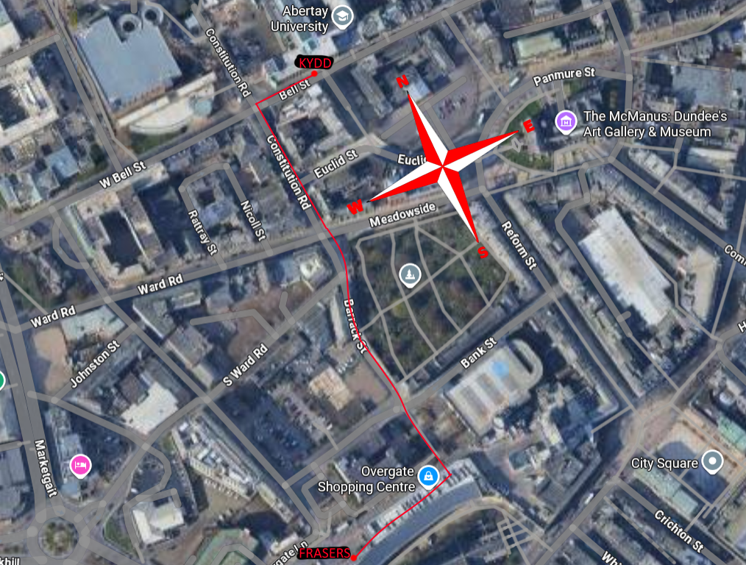
Pseudocode:

1. Initialise time, location
2. Check Current Time
2.1 If time is between 9AM and 6PM
2.2 Continue
2.3 If time is NOT between 9AM and 6PM
2.4 Repeat
3. Follow footpath west to the end of Bell St
4. Follow the footpath down Constitution Road
5. While at junction
5.1 If Right AND Left is clear
5.2 Cross road to Barrack Street
5.3 Else
5.4 Wait 5 seconds
5.5 Repeat
6. Follow the footpath down Barrack Street
7. While at junction
7.1 If Right AND Left is clear
77.2 Cross road and follow path into Overgate
7.3 Else
7.4 Wait 5 seconds
7.5 Repeat
8. If inside Overgate
8.1 Go west till end
8.2 Else go straight // edgecase in case robby hasn’t fully reached the inside
8.3 Repeat
9. Stop in front of Frasers

Marking Scheme
Criteria | Description | Marks
1. Initialization & Setup | Properly initializes Robby’s starting point and variables (e.g., current time, location). | 2
2. Time Check Logic | Includes a decision structure to check if the current time is within shop opening hours before proceeding. | 2
3. Road Safety Logic | Implements logic to ensure Robby checks for safe road crossing . | 3
4. Navigation Logic | Uses logical approach to guide Robby through the route. | 3
5. Use of Programming Constructs | Appropriate use of loops, decision statements. | 2
6. Clarity and Structure | Pseudocode is logically structured, easy to follow, and uses consistent formatting. | 2
7. Error Handling / Edge Cases | Accounts for potential issues. | 1

